**IJARCCE**



ISSN (Online) 2278-1021

ISSN (Print) 2319 5940

**International Journal of Advanced Research in Computer and Communication Engineering**

**ISO 3297:2007 Certified**

Vol. 6, Issue 3, March 2017

Literature Review on Home Automation System

**Neha Malik1, Yogita Bodwade1**

Government College of Engineering, Jalgaon, India1

**Abstract:** One of the topics which is gaining popularity is Home Automation System because of itsinnumerousadvantages. Home automation refers to the monitoring and controlling of home appliances remotely. with the never - ending growth of the Internet and its applications, there is much potential and scope for remote access and control and monitoring of such network enabled appliances. This paper deals with discussion of different intelligent home automation systems and technologies from a various features standpoint. The effort targeted on the home automation concept of where the controlling and monitoring operations are expediting through smart devices. Wide-ranging home automation systems and technologies considered in review with central controller based (Arduino or Raspberry pi), cloud-based, Bluetooth-based, SMS based, ZigBee based, mobile-based, RF Module based, web based and the Internet with performance.

**Keywords:** Home Automation, Intelligence, Microcontroller, Sensor System, User-friendly Interface.

|  |  |  |
| --- | --- | --- |
| **I. INTRODUCTION** |  |  |
| Automation performs an increasingly vital role in daily | **Challenges of Home automation systems** | |
| experience and global economy. Engineers strive to | Home automation systems suffers four main challenges; | |
| combine automated devices with mathematical and | these are poor manageability, inflexibility, difficulty in | |
| organizational tools to create complex systems for a | achieving securityand high cost of ownership,The main | |
| rapidly expanding range of applications and human | objectives of this research is to design and implement a | |
| activities. | home automation system using IoT that is capable of | |
|  | controlling and automating most of the house appliances | |
| The concept of home automation has been around since | through an easy manageable web interface. The proposed | |
| the late 1970s. But with the enhancement of technology | system has a great flexibility by using Wi-Fi technology to | |
| and smart services, people’s expectations have changed a | interconnect its distributed sensors to home automation | |
| lot during the course of time to perfectly turn the | server. This will decrease the deployment cost and will | |
| traditional house into smart home, and also think that what | increase the ability of upgrading, and system | |
| a home should do or how the services should be provided | reconfiguration. | |
| and accessed at home to became a smart home and so has |  |  |
| the idea of home automation systems. |  | **II. LITERATURE SURVEY** |
| A home automation system means to grant the endusers to | **1.** | **Bluetooth based home automation system** |
| manage and handle the electric appliances. If we look at | **using cell phones:** | |
| different home automation systems over time, they have | In Bluetooth based home automation system the home | |
| always tried to provide efficient, convenient, and safe | appliances are connected to the Arduino BT board at input | |
| ways for home inhabitants to access their homes. | output ports using relay. The program of Arduino BT | |
| Regardless of the change in user’s hope, growing | board is based on high level interactive C language of | |
| technology, or change of time, the appearance of a home | microcontrollers; the connection is made via Bluetooth. | |
| automation system has remained the same. | The password protection is provided so only authorized | |
|  | user is allowed to access the appliances. The Bluetooth | |
| Many existing, well-established home automation systems | connection is established between Arduino BT board and | |
| are based on wired communication such as Arduino based | phone for wireless communication. In this system the | |
| and raspberry pi based home automation systems. This | python script is used and it can install on any of the | |
| does not pose a problem until the system is planned well in | Symbian OS environment, it is portable. One circuit is | |
| advance and installed during the physical construction of | designed and implemented for receiving the feedback from | |
| the building. But for already existing buildings the | the phone, which indicate the status of the device. | |
| implementation cost goes very high. In contrast, Wireless |  |  |
| systems can be of great help for automation systems like | **2.** | **Zigbee based home automation system using** |
| Bluetooth, Wi-Fi and IOT based home automation | **cell phones:** | |
| systems. With the advancement of wireless technologies | To monitor and control the home appliances the system is | |
| such as Wi-Fi, cloud networks in the recent past, wireless | designed and implemented using Zigbee. The device | |
| systems are used every day and everywhere. | performance is record and store by network coordinators. | |

Copyright to IJARCCE **DOI10.17148/IJARCCE.2017.63173** 733

**IJARCCE**



ISSN (Online) 2278-1021

ISSN (Print) 2319 5940

**International Journal of Advanced Research in Computer and Communication Engineering**

**ISO 3297:2007 Certified**

Vol. 6, Issue 3, March 2017

For this the Wi-Fi network is used, which uses the four remote users can access server web based application

switch port standard wireless ADSL modern router. The through the internet using compatible web browser.

network SSID and security Wi-Fi parameter are Software of the latest home automation system is split to

preconfigured. The message for security purpose first server application software, and Microcontroller (Arduino)

process by the virtual home algorithm and when it is firmware. The Arduino software, built using C language,

declared safe it is re-encrypted and forward to the real using IDE comes with the microcontroller itself. Arduino

network device of the home. Over Zigbee network, Zigbee software is culpable for gathering events from connected

controller sent messages to the end. The safety and sensors, then applies action to actuators and pre-

security of all messages that are received by the virtual programed in the server. Another job is to report the and

home algorithm. To reduce the expense of the system and record the history in the server DB. The server application

the intrusiveness of respective installation of the system software package for the proposed home automation

Zigbee communication is helpful. system, is a web based application built using asp.net. The

server application software can be accessed from internal

1. **GSM based home automation system using** network or from internet if the server has real IP on the

**cell phones:** internet using any internet navigator supports asp.net

Because of the mobile phone and GSM technology, the technology. Server application software is culpable of,

GSM based home automation is lure to research. The SMS maintain the whole home automation system, setup,

based home automation, GPRS based home automation configuration. Server use database to keep log of home

and dual tone multi frequency (DTMF) based home automation system components, we choose to use XML

automation, these options we considered mainly for files to save system log.

communication in GSM.

In figure shows the logical diagram the work of A. Alheraish, it shows how the home sensors and devices interact with the home network and communicates through GSM and SIM (subscriber identity module). The system use transducer which convert machine function into electrical signals which goes into microcontroller. The sensors of system convert the physical qualities like sound, temperature and humidity into some other quantity like voltage. The microcontroller analysis all signal and convert them into command to understand by GSM module. Select appropriate communication method among SMS, GPRS and DTFC based on the command which received GSM module.

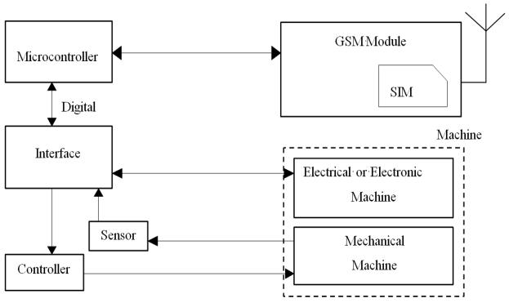

**Figure.** Mobile-based home automation from the work ofA. Alheraish

**Fig. The proposed home automation system layout**

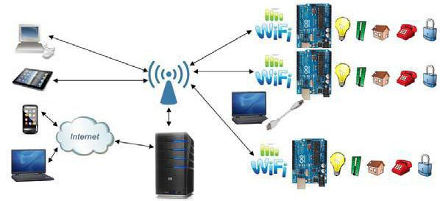

1. **Home automation using RF module:**

The important goal of Home Automation System is to [build a home automation system](http://www.edgefxkits.com/touch-screen-based-home-automation-system) using a RF controlled remote. Now technology is accelerating so homes are also getting smarter. Modern homes are deliberately relocating from current l switches to centralized control system, containing RF controlled switches. Todaytraditional wall switches situated in various parts of the home makes it laborious t for the end user to go near them to control and operate. Even further itturnsinto moreproblematic for the old persons or physically handicapped people to do so. Home Automation using remote implements an easier solution with RF technology.

In order to accomplish this, a RF remote is combined to the microcontroller on transmitter side that sends ON/OFF

1. **Wi-Fi based home automation system using** signals to the receiver where devices are connected. By

|  |  |  |
| --- | --- | --- |
| **cell phones:** | operating the stated remote switch on the transmitter, the | |
| Wi-Fi based home automation system mainly consist three | loads can be turned ON/OFF globally using wireless | |
| modules, the server, the hardware interface module, and | technology. | |
| the software package. The figure shows the system model |  |  |
| layout. Wi-Fi technology is used by server, and hardware | **6.** | **Home automation using Android ADK:** |
| Interface module to communicate with each other. The | The devices of home are associate to the ADK and the | |
| same technology uses to login to the server web based | Connection is established between the Android device and | |
| application. The server is connected to the internet, so | ADK. The devices of house are link to the input/output | |

Copyright to IJARCCE **DOI10.17148/IJARCCE.2017.63173** 734

**IJARCCE**



ISSN (Online) 2278-1021

ISSN (Print) 2319 5940

**International Journal of Advanced Research in Computer and Communication Engineering**

**ISO 3297:2007 Certified**

Vol. 6, Issue 3, March 2017

|  |  |  |
| --- | --- | --- |
| ports of the board (EMBEDDED SYSTEM) and their | **8.** | **Raspberry pie home automation with wireless** |
| current situation will have passed to the ADK. The | **sensors using smart phone** | |
| microcontroller board (Arduino ADK) is based on the | Home Automation System has been developed with | |
| ATmega2560. It has a USB host connection to associate | Raspberry Pi by reading the algorithm and subject of E- | |
| with Android based phones, and that is based on the | mail. Raspberry Pi guarantees to be an efficient platform | |
| MAX3421e IC. The two important features of Android | for implementation powerful, and economic smart home | |
| Open Accessory Protocol 2.0(AOAP) are as follows: | automation. home automation using Raspberry pi is better | |
|  | than any other home automation methods in several ways. | |
| It has audio output that is from the Android device to the | For example, DTMF (dual tone multi-frequency) using | |
| component and it also support for the component serves as | home automation, the call tariff is a big demerit, which is | |
| one or more Human Interface Devices (HID) to the | not the problem in their proposed method. In Home | |
| Android device. This paper depends upon Android and | Automation using web server, the design of web server | |
| Arduino platform in which both are FOSS(Free Open | and the memory space required is dismiss by this method, | |
| Source Software). Including motion sensors for safety | because it just uses the already established web server | |
| systems will detect an unauthorized action and it will | service given by G-mail. LEDs were used to identify the | |
| automatically notice the user through cell phone or the | switching action. This System is efficient and flexible | |
| security system. | interactive. | |

|  |  |  |
| --- | --- | --- |
| **7.** | **Cloud Based home automation system:** | **Sending Commands to the Raspberry Pi** |
| Home Automation using cloud based system focuses on | | The script running on server side of our laptop or on a web |
| design and implementation of home gateway to collect | | server receives the input commands from the user and |
| data about data from home appliances and then send to the | | appropriately sends it to the client (Raspberry Pi). Inthis, |
| cloud-based data server to get store on Hadoop Distributed | | we will be using those input commands to turn a light |
| File System, it is process using MapReduce and use to | | ON/OFF. When we give the command to turn ON a light |
| implement a monitoring tasks to Remote user Presently | | by the server side script, the data and information gets |
| home Automation System is persistently developing its | | relayed to the Raspberry Pi and its GPIO pin will turns ON |
| resilience by assimilating the current characteristics which | | a relay. The system can send current updates to the server |
| gratify the rising interest of the people. This paper presents | | to detect whether the light is ON/OFF. |

the design and development of home automation system that use the cloud computing as service. The current system consists of three important units: the first part is cloud server, handle and controls the data and information of client and users and the status of devices The hardware interface module is the second part which implement the relevant connection to the actuators and sensing devices which give the physical service. Last part is Home Server, which construct the hardware device and gives the user interface. This paper focus to build the web services using cloud which is need for security and storage and availability of the data. The current system is cost efficient, reliable and comfortable which also gives a secured home automation system for entire family.

The system is made up of various client modules for various platforms.

1. Cloud server

Cloud Server is a central server aims on implementing services to the other sub modules. Central server serves as the data respiratory system and brain It implementsthree connections to the three sub modules vizhome system, web configuration tool and mobile. The server evaluatesthe data it takes from the house, send current status to the mobile device and vice versa. A database is managing by the server and it is status gets updated as per the changes done at home end.

* 1. Embedded Program for Hardware Circuit Microcontroller, and.

1. Internet Client for any desktop or mobile phones.

**Fig.** Sending Commands to Raspberry pi

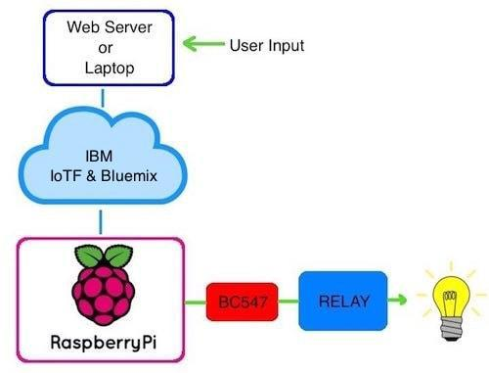

**Receiving Data from the Raspberry Pi**

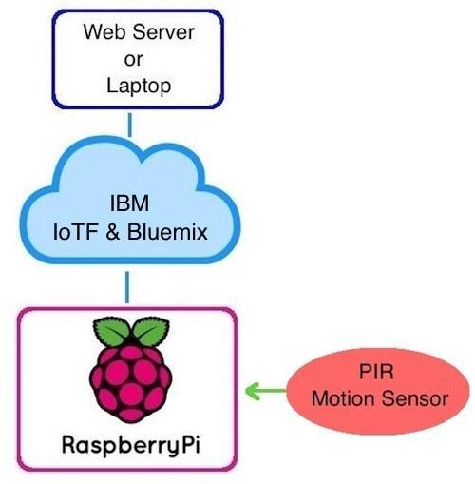

**Fig.** Receiving data from Raspberry pi

Copyright to IJARCCE **DOI10.17148/IJARCCE.2017.63173** 735

**IJARCCE**



ISSN (Online) 2278-1021

ISSN (Print) 2319 5940

**International Journal of Advanced Research in Computer and Communication Engineering**

**ISO 3297:2007 Certified**

Vol. 6, Issue 3, March 2017

Using PIR motion sensor we can send the data signal to of server i.e. Wi-Fi module, sensors. Server controls and

the Raspberry Pi, we just run a script which can reads the monitors the various sensors, and can be easily configured

sensor by a GPIO pin and transmit the data to overall to handle more hardware interface module (sensors). The

system through the IoTF platform. This can then be look Arduino board, with built in Wi-Fi module acts as web

by the IoTFconsole. server. Automation System can be accessed from the web

browser of any local PC using server IP, or remotely from

1. **Wireless Home Automation system using IoT** any PC or mobile handheld device connected to theThis system uses mobiles or computers to control basic internet with appropriate web browser through server real home control and function automatically through internet IP (internet IP). Wi-Fi technology is selected to be the from anywhere around the worldglobally, an automated network infrastructure that connects server and the home is sometimes called a smart home. It is meant to sensors. Wi-Fi is chosen to improve system security (by save the electric power and human energy. The proposed using secure Wi-Fi connection), and to increase system

|  |  |  |  |  |  |  |
| --- | --- | --- | --- | --- | --- | --- |
| system is a distributed home automation system, consists | | | | mobility and scalability. | |  |
|  |  |  | **III. COMPARISON** | |  |  |
|  |  |  |  |  |  |  |
| **Serial** | **System** | **Communicati** | **Controller** | **User** | **Applications** | **Merits** |
| **no.** |  | **on Interface** |  | **Interface** |  |  |
| 1 | Wi-Fi based | Wi-Fi | Arduino | Web | Temperature and | Low cost, |
|  | using Arduino |  |  | Application | motion detection, | Secure, |
|  | microcontrolle |  |  | and android | monitoring and | Remotely |
|  | r through IOT |  |  | App | controlling | controlled |
|  |  |  |  |  | appliances |  |
| 2 | Smart Task | Wired X10 | Arduino | Android | Energy Management | Energy-efficient |
|  | Scheduling | and Wireless |  | Application | and task scheduling | and |
|  | Based | Zig bee |  |  | with power and cost | Highly scalable |
|  | using Arduino |  |  |  |  |  |
|  | and Android |  |  |  |  |  |
| 3 | Web service | Web server | Raspberry | Android | Controlling shutter of | Autonomous, |
|  | and android | and interface | pi | application | window | and Quite |
|  | app Based | card |  |  |  | scalable |
|  | using |  |  |  |  |  |
|  | Raspberry pi |  |  |  |  |  |
| 4 | Cloud Based | Cloud based | Home | Smart | Monitoring and | Effectively |
|  | Using Hadoop | data server | gateway | device | Controlling Home | manage |
|  | System | uses Hadoop | and router |  | Appliances | Semi structured |
|  |  | technology |  |  |  | and |
|  |  |  |  |  |  | unstructured |
|  |  |  |  |  |  | data, Reduce |
|  |  |  |  |  |  | computational |
|  |  |  |  |  |  | burden of smart |
|  |  |  |  |  |  | devices |
| 5 | Cloud Based | Zig bee | Smart | PC or | entrance control | Convenience, |
|  | Using Zig Bee | wireless | Socket | Android | management, | safety, |
|  | Microcontrolle | Network |  | Phone | monitoring the power | and Power- |
|  | r |  |  |  | consumption, | saving |
|  |  |  |  |  | temperature |  |
|  |  |  |  |  | and humidity |  |
| 6 | Wireless | cloud-based | PCB | Mobile | monitor the home | Low power |
|  | Sensors Based | data server | circuits | Application | conditions and power | consumption |
|  | with mobile |  |  |  | consumption of | And system cost |
|  | Technology |  |  |  | appliance | efficiency. |
| 7 | Android based | Micro Web | Arduino | Android | Light | Feasibility and |
|  | using Arduino | Server | Mega 2560 | App | switches, | Effectiveness |
|  |  |  | and the |  | Temperature, |  |
|  |  |  | Arduino |  | Humidity sensors, |  |
|  |  |  | Ethernet |  | Intrusion detection, |  |
|  |  |  | shield |  | Smoke/Gas sensor |  |

Copyright to IJARCCE **DOI10.17148/IJARCCE.2017.63173** 736

**IJARCCE**



ISSN (Online) 2278-1021

ISSN (Print) 2319 5940

**International Journal of Advanced Research in Computer and Communication Engineering**

**ISO 3297:2007 Certified**

Vol. 6, Issue 3, March 2017

|  |  |  |  |  |  |  |
| --- | --- | --- | --- | --- | --- | --- |
| 8 | Konnex-Bus | SIP Provider | Raspberry | Mobile App | Lights Control, | Performance |
|  | based using |  | pi and |  | Temperature | improved, |
|  | raspberry pi |  | Konnex |  | Monitoring | energy- |
|  |  |  | Bus |  |  | consumption |
|  |  |  |  |  |  | could be |
|  |  |  |  |  |  | Reduced. |
| 9 | Bluetooth | Bluetooth | Arduino | Python | controlling | Secured and |
|  | Based using |  |  | supported |  | Low cost |
|  | Arduino |  |  | mobile |  |  |
| 10 | GSM Based | SMS | Arduino | Smartphone | Control appliances | Simplicity |
|  | Using Arduino |  |  | App |  |  |
|  |  |  |  |  |  |  |

**IV. CONCLUSION**

Survey of different home automation system shows that there are various kinds of technologies used to implement this type of system. All the proposed systems have been presented and compared in this paper which reveals some merits and demerits of the systems. This review explained different home automation system e.g. Web based, Bluetooth-based, mobile-based, SMS based, ZigBee-based, Arduino microcontroller based, Android app based, IOT based and cloud-based. Due to its performance, simplicity, low cost and reliabilityhome automation system is making its position in global market,that day is not so far when every home will be the smart home.

**REFERENCES**

1. Yadnya Adhiya, Shriya Ghuge, H.D Gadade “A survey on home automation system using IOT” IJRITCC Volume_5_Issues-March_17_Volume_5_Issue_3
2. Kim Baraka, Marc Ghobril, Sami Malek, RouwaidaKanj,

AymanKayssi “Low cost Arduino/Android-based Energy-Efficient Home Automation System with Smart Task Scheduling”, 2013 Fifth International Conference on Computational Intelligence, Communication Systems and Networks.

1. HayetLamine and HafedhAbid,” Remote control of a domestic equipment from an Android application based on Raspberry pi card”, IEEE transaction 15th international conference on Sciences and Techniques of Automatic control & computer engineering - STA'2014, Hammamet, Tunisia, December 21-23, 2014.
2. YunCui, MyoungjinKim, YiGu, Jong-jinJung, and HankuLee,

“Home Appliance Management System for Monitoring Digitized

Devices Using Cloud Computing Technology in Ubiquitous Sensor

NetworkEnvironment”,HindawiPublishingCorporation

International Journal of Distributed Sensor Networks Volume 2014, Article ID 174097

1. Shih-Pang Tseng, Bo-Rong Li, Jun-Long Pan, and ChiaJuLin,”An Application of Internet of Things with Motion Sensing on Smart House“, 978-1-4799-6284-6/14 c ⃝2014 IEEE.
2. Kim Baraka, Marc Ghobril, Sami Malek, RouwaidaKanj, AymanKayssi,” SmartPower Management System For Home Appliances And Wellness Based On Wireless Sensors Network

And Mobile Technology”, ,2015 XVIII AISEM Annual

Conference, 978-1-4799-8591-3/15©2015 IEEE

1. Shiu Kumar,” UBIQUITOUS SMART HOME SYSTEM USING ANDROID APPLICATION “, International Journal of Computer Networks & Communications (IJCNC) Vol.6, No.1, January 2014.
2. Jan Gebhardt, Michael Massoth, Stefan Weber and TorstenWiens,

“Ubiquitous Smart Home Controlling Raspberry Embedded System”, UBICOMM: The Eighth International Conference on Mobile Ubiquitous Computing, Systems, Services and Technologies, 2014.

1. BakiKoyuncu, “PC Remote Control of Appliances by Using Telephone Lines”, 1995, IEEE Transactions on Consumer

Electronics,Vol. 41(1), pp. 201-209.

1. Greichen, J.J., “Value based home automation or today's market,”

IEEE Transactions on Consumer Electronics, vol. 38, no. 3, pp.34-38, Aug. 1992

1. Alheraish, “Design and Implementation of Home Automation System,” IEEE Transactions on Consumer Electronics, vol. 50, no. 4, pp.1087-1092, Nov. 2004.

Copyright to IJARCCE **DOI10.17148/IJARCCE.2017.63173** 737